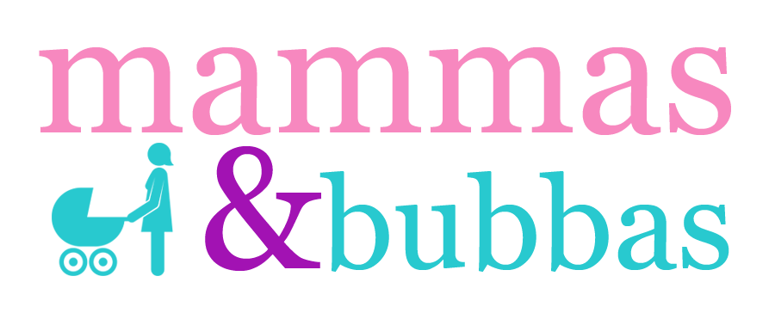

Health Screening and Consent Form

Name |  | Email Address
Address |  | GP Name / Surgery Address
Mobile No |  | Date of Birth
Home Number |  | Occupation
Baby’s Name |  | Baby’s Date of Birth
Emergency  contact and number |  | Relationship to you
Number of other children |  | Post Natal Bleeding Status

How did you hear about Mammas Fitness classes eg. friend, poster, internet, flyer etc.?

The following information is to ensure the exercise is as safe and appropriate for you as possible. Please read the questions carefully and answer each one honestly. (All answers will be treated with the strictest of confidence).

What type of delivery did you have – Natural or C-Section?

Did you have an episiotomy?

If so, did you have any stitches?

Have you had your 6-10 week, post-natal check-up?

In NO, you must wait until you have had your check up before participating in any class. Please make sure your doctor gives you the all clear to exercise at your check-up.

If YES, were you given the all clear to exercise?

Are you currently pregnant? If YES, how many weeks pregnant are you?

Are you breastfeeding?

Did you develop any pelvic pain during pregnancy or after delivery?

Currently, or while pregnant did you suffer any of the following conditions? Please circle if YES

Symphysis Pubis Dysfunction (pain in the pubic area) | Sacrum or Sacroiliac joint pain (pain in the very lower back) | Bleeding during or after exercise of any unexplained bleeding
Carpal Tunnel Syndrome (wrist/finger pain/numbness or tingling) | Knee pain (front/side) | Depression
Upper back/neck/shoulder pain | Coccyx damage or pain | Separation or your abdominal muscles
Incontinence (urinary or faecal) | Prolapse | Breast health/breast feeding issues
Piles/hemorrhoids | Varicose veins | Nerve damage during birthing
Gestational diabetes | C-Section wound discomfort or slow healing or numbness | Muscular pain
Joint pain | Buttock/piriformis pain/sciatica | Episiotomy or tears

Please put an “X” in the appropriate column. If you answer “Yes” to any question, please give details. IMPORTANT – If you answer YES to any of the following questions below, you must consult your GP before attending the class.

 | YES | NO
Do you have or have you ever had a known heart condition e.g. previous heart attack, stroke, abnormal ECG, palpitations, murmurs?

Is there a history of heart conditions in your family?

Do you ever feel pain in your chest when you exercise or do physical activity?

Do you often feel faint or have spells of dizziness or lose consciousness?

Do you have, or have you ever had a bone or joint condition that could be made worse by exercise or that could prevent you from exercising?
Do you have high blood pressure? If yes, is this pregnancy related and how is it being treated?
Do you have any other medical conditions not mentioned (e.g. Asthma, Diabetes, Arthritis, Gout, Epilepsy, Hernia, Dizziness, Circulation problems, Ulcer)?
If yes, please provide details here:
Are you currently taking any prescribed medication? If yes, please give details.

Do you know of any other condition that might be reason for you not to exercise?

Do you have an injury or illness that could be made worse by exercise? If YES, please give details:

Exercise History]

Did you exercise DURING pregnancy? If yes, please give details in the ‘further information’ box below.

Did you exercise BEFORE pregnancy? If yes, please give details in the box below.

Are you CURRENTLY exercising? If yes, please give details in the box below.

What are you goals for exercising?

Further Information Please enter below any additional information you think the instructor should be made aware of.

Informed Consent

I confirm that I have completed the above questionnaire to the best of my ability and that I have provided accurate information regarding my current health status. I take it upon myself to discuss any changes in my health with the instructor. I am voluntarily participating in the activities of Mammas Fitness classes and will immediately discontinue any activity if I feel any symptoms of distress or discomfort, and will notify my instructor. I take part at my own risk and I waive any legal recourse for damages to myself, my child or property arising from my participation. I understand that I am free to withdraw at any time but that no refund will be issued. The information obtained by the instructor will be treated as privileged and confidential.

I further understand and acknowledge that the instructors of Mammas Fitness are not Health or Medical Practitioners and therefore cannot diagnose or treat individual health or medical problems. All such questions and concerns should be directed to my General Practitioner.

Client's Signature: ___________________________________ Date: _________________

Instructor's Signature: ________________________________ Date: _________________

Photo Consent

We would be grateful if you would fill in this form to give us permission to take photos of you and your child and use these in our printed and online publicity.

I give Mammas Fitness permission to take photographs and / or video of me and my child during classes. I grant full rights to use the images resulting from the photography/video filming, and any reproductions or adaptations of the images for fundraising, publicity or other purposes to promote Mammas Fitness. This might include (but is not limited to), the right to use them in their printed and online publicity, social media and press releases.

Client’s Signature: ___________________________________ Date: _________________

Data Consent

We would like to use your Personal Data to keep you up to date with the latest news and offers from Mammas Fitness and our partners by email. We would also like to keep in touch using your mobile telephone number via WhatsApp for your particular class.

We would like to reassure you that we do not share your personal information with any 3rd party organisations for marketing purposes and you have the right to ask us to update, correct or delete your personal data at any time.

To read our Privacy Policy in full, please visit www.mammasfitness.com.

Yes please I would like to receive information via email

Yes please I would like to receive information via mobile telephone
No thank you

